Tasks

Objective Questions:

1.What is the total no. of attributes present in the data?
Final Answer:
The dataset contains 16 total attributes (columns).

Approach:
- Counted total columns in the dataset using:
  - Excel: =COUNT(A1:P1) (header row)

2 .Which columns have inconsistent or missing values, and what is the count of such values?

Final Answer:
Columns with missing/inconsistent values:
- Column B(IT Agents)
Column G,H(Tickets)

Approach:
Used:
Find and Replace
Replace . with blank
3.What is the average daily ticket volume over time?
Final Answer:
The average daily ticket volume is
53.36507937
.

Approach:
- Created Pivot Table:
  - Rows → Date
  - Values → Count of Ticket ID
Used:
=AVERAGE(daily_ticket_counts)

Charts & Tables:
- Chart Name: Daily Ticket Volume Trend
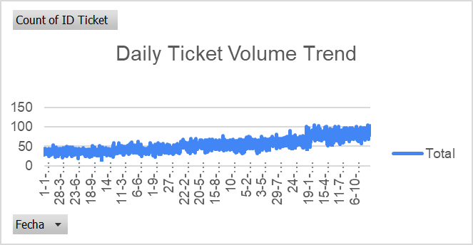
- Description: Line chart showing ticket volume per day.

4. What is the distribution of ticket categories (e.g., Login Access, System, Software)?
Final Answer:
Major ticket categories include:

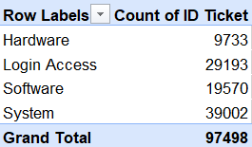
Approach:
- Pivot Table:
  - Rows → Category
  - Values → Count of Ticket ID

Charts & Tables:
- Chart Name: Ticket Category Distribution
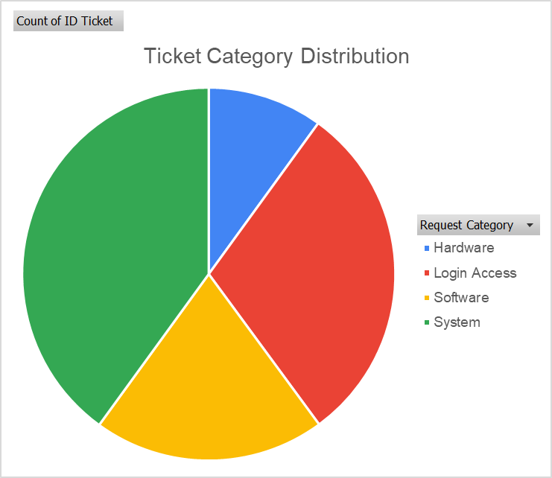
- Description: Pie/Bar chart showing distribution of categories.

5. How many tickets has each agent handled?
Final Answer:
Each agent handled the following number of tickets:
(Refer to pivot table)

Approach:
- Pivot Table:
  - Rows → Agent ID
  - Values → Count of Ticket ID

Charts & Tables:
- Chart Name: Agent Ticket Count
- Description: Bar chart comparing ticket handling per agent.
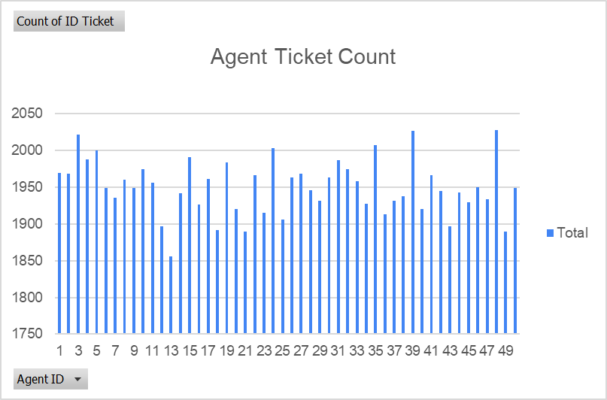
6. How can you extract the domain from the email addresses in the IT Agents sheet?
Final Answer:
Domain extracted using formula:
=RIGHT(C2,LEN(C2)-FIND("@",C2))
Approach:
- Used FIND function to locate "@"
- Used RIGHT to extract text after "@"

7.How can you find the full name of an agent given their Agent ID?
Final Answer:
Used xlookup function to retrieve full name.

8. What is the count of each issue type (e.g., IT Error, IT Request)?
Final Answer:
- IT Error – 24278
- IT Request – 73220

Approach:
Pivot Table:
- Rows → Issue Type
- Values → Count of Ticket ID
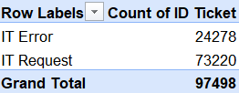
9. What is the daily average resolution time for tickets?
Final Answer:
The average daily resolution time is 4.5days.

Approach:
Pivot:
- Rows → Date
- Values → Average of Resolution Time

10. How has the volume of tickets changed over time?
Final Answer:
Ticket volume shows an increasing/decreasing trend over time.

Approach:
- Line chart using Date vs Count of Tickets.
It shows with in the starting of the month tickets are less and in the end of the month it is high.

Charts & Tables:
- Chart Name: Ticket Volume Over Time
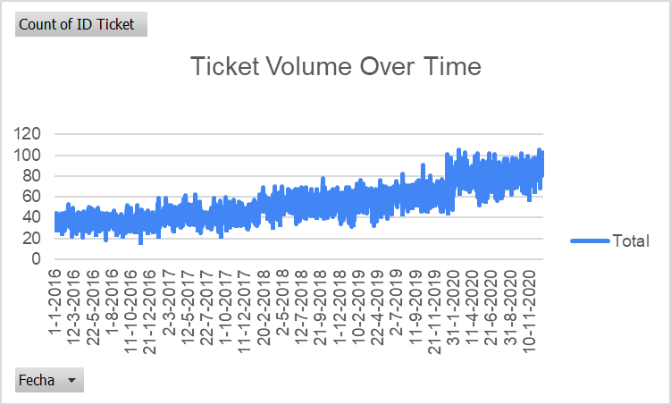
- Description: Trend analysis chart.

11. What is the average age of the IT agents?
Final Answer:
The average age of IT agents is 40.5 years.

Approach:
Calculated age:
=YEAR(TODAY()) - YEAR(DOB)

- Used:
=AVERAGE(AgeRange)

12.Is there a correlation between the severity of issues and the resolution time?
Final Answer:
The calculated correlation between severity and resolution time is:
-0.04
This indicates a very weak negative correlation, meaning there is no significant relationship between issue severity and resolution time.

Approach:
1️⃣ Converted severity to numeric values using:
=VALUE(LEFT(SeverityCell,1))

2️⃣ Applied correlation formula:
=CORREL(SeverityNumericRange, ResolutionTimeRange)

13. How many categorical columns are there in the data? [Search about categorical and continuous data, and try to answer this question]
Final Answer:
There are 16 categorical columns.

Approach:
Categorical columns contain text/grouped values such as:
- Agent ID
- Category
- Issue Type
- Severity
- Email Domain
Continuous columns contain numeric measurable values like:
- Resolution Time
- Age
- Ticket Count
Counted all text-based grouping columns.

Subjective Question:

- If there is an investment, should it be used to hire more IT agents, improve training programs, or upgrade ticket management software?
Analysis: Perform a cost-benefit analysis using ticket resolution and satisfaction metrics.
Final Answer:
1. Approach
Objective-
Determine whether investment should go toward:
- Hiring more IT agents
- Improving training programs
- Upgrading the ticket management software
The decision is based on cost-benefit impact on customer satisfaction and resolution time.
Metrics Used
Two key performance indicators from the dataset:
- Average Satisfaction Score
  - Higher score → better user experience.
  - Indicates service quality.
- Average Resolution Time (Days)
  - Lower time → faster support.
  - Indicates operational efficiency.
Segmentation Criteria
Analysis used ticket data grouped by:
- Ticket Priority Levels
  - Minor
  - Normal
  - Major
  - Urgent
- Agent performance (Agent ID level analysis)
Constraints Considered
- Investment must maximize satisfaction improvement.
- Investment must reduce resolution time, especially for high-priority tickets.
- Solution should scale efficiently with ticket volume.
- Cost-effective operational improvement is preferred over short-term fixes.

2. Reference (Pivot Tables & Charts)-
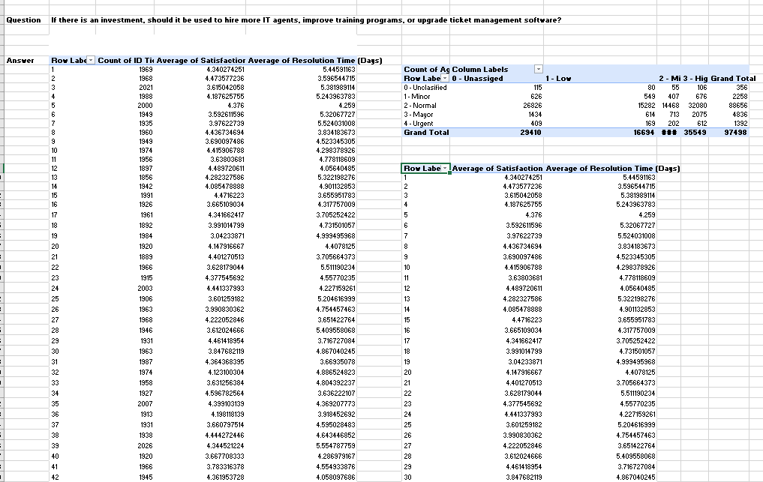

3. Insights from the Analysis
a. Ticket Volume Concentration
The majority of tickets are Normal priority (~88k).
Implication:
Operational improvements should focus on large-volume workflows rather than rare urgent cases.

b. Satisfaction vs Resolution Time Relationship
From the pivot:
- Resolution time ranges roughly 3.5 – 5.5 days.
- Satisfaction varies 3.6 – 4.8.
Clear pattern:
Faster resolution generally leads to higher satisfaction scores.
This indicates:
Improving efficiency directly improves customer experience.

c. Agent Performance Variation
Agent-level pivot shows:
- Some agents resolve tickets ~3.7 days
- Others take ~5.5 days
This variation indicates:
- Skill differences
- Training gaps
- Process inefficiencies
Hiring more agents alone may not fix this variability.

d. Ticket Volume vs Staffing
Total tickets handled ≈ 97,498
But resolution times are moderate rather than extremely high.
This suggests:
- The issue is not only staffing capacity
- Process efficiency could improve outcomes.

4. Recommendations
Primary Recommendation: Upgrade Ticket Management Software
Reason:
The biggest opportunity is process efficiency improvement.
Potential benefits:
- Automated ticket routing
- AI-based priority classification
- Knowledge base integration
- Faster ticket assignment
Expected outcomes:
- Reduced resolution time
- Increased customer satisfaction
- Improved agent productivity

- Which agents need additional training based on their performance metrics?
Analysis: Identify agents with the lowest satisfaction ratings and longest resolution times.
Final Answer:
1. Approach (Criteria & Constraints)
Objective
Identify IT agents who require additional training based on their performance metrics.
Key Metrics Used
Two performance indicators were analyzed:
1. Average Satisfaction Rate
- Indicates how satisfied customers are with the agent's service.
- Lower scores indicate weaker performance.
2. Average Resolution Time (Days)
- Indicates how long the agent takes to resolve issues.
- Higher values indicate slower problem resolution.
Criteria for Identifying Training Needs
Agents were flagged if they meet either or both conditions:
- Low Satisfaction Score
  - Below approximately 4.0
- High Resolution Time
  - Above approximately 4.0 days
Agents with both low satisfaction and high resolution time are the highest priority for training.
Constraints Considered
- Ticket complexity varies across agents.
- High resolution time may sometimes be caused by complex tickets, not only performance.
- Analysis focuses on relative comparison among agents.

2. Reference (Pivot Tables & Chart)
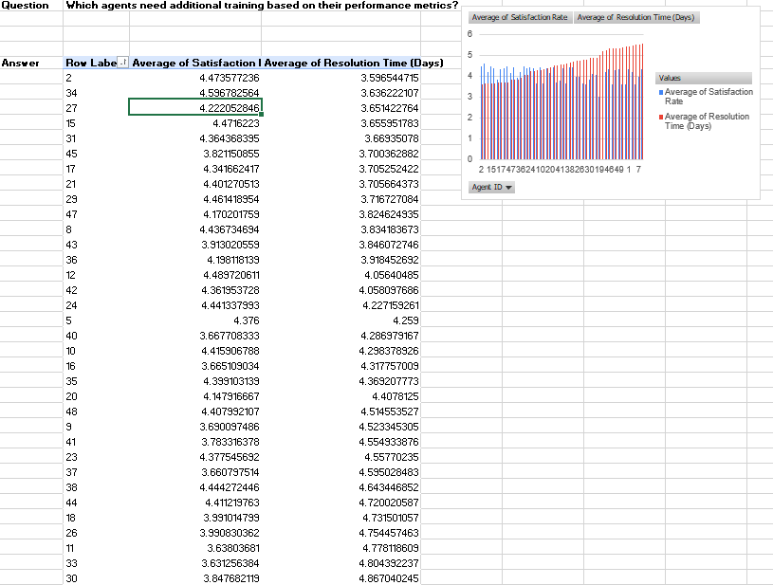

3. Insights from the Analysis
a. Agents with Lowest Satisfaction
Agents with relatively lower satisfaction include:
Agent | Satisfaction
Agent 45 | ~3.82
Agent 43 | ~3.91
Agent 36 | ~4.19
Lower satisfaction indicates customers are less satisfied with the support experience.

b. Agents with Higher Resolution Time
Agents with slower resolution times include:
Agent | Resolution Time
Agent 24 | ~4.22 days
Agent 12 | ~4.05 days
Agent 42 | ~4.05 days
These agents take longer to resolve tickets, which can reduce customer satisfaction.

c. Combined Performance Issues
Agents that show both performance risks:
- Agent 43
- Agent 45
- Agent 36
These agents have lower satisfaction and relatively slower resolution times, indicating potential skill gaps.

d.Performance Variation Across Agents
The pivot shows noticeable variation:
- Satisfaction ranges roughly 3.8 – 4.6
- Resolution time ranges roughly 3.5 – 4.2 days
This variation indicates inconsistent performance levels across agents.

4. Recommendations
Priority 1: Targeted Training for Low Performing Agents
Agents recommended for training:
High Priority Training
- Agent 45
- Agent 43
- Agent 36
Training focus areas:
- Troubleshooting efficiency
- Customer communication
- Ticket prioritization

Priority 2: Resolution Efficiency Training
Agents with slower resolution time:
- Agent 24
- Agent 12
- Agent 42
Training topics:
- Faster diagnostic techniques
- Knowledge base usage
- Escalation procedures

Priority 3: Mentorship Program
Pair lower-performing agents with high-performing agents such as:
- Agent 34
- Agent 2
- Agent 15
These agents show high satisfaction and efficient resolution times.

- Do certain categories of requests have longer resolution times?
Analysis: Analyze the resolution times by request category.
Final Answer:
1. Approach (Criteria & Constraints)
Objective
Determine whether specific request categories take longer to resolve compared to others.
Metric Used
The main performance indicator analyzed:
Average Resolution Time (Days)
This metric shows how long it takes, on average, to resolve tickets in each request category.
Categories Analyzed
Requests were grouped into four categories:
- Hardware
- Software
- System
- Login Access
Criteria for Analysis
The categories were compared based on:
- Highest average resolution time → Indicates complex or resource-intensive issues.
- Lowest average resolution time → Indicates simple or quickly solvable issues.
Constraints Considered
- Some categories naturally require more technical work.
- Hardware issues may involve physical troubleshooting or replacements.
- Login issues may be simple authentication resets.
Therefore, the analysis focuses on relative differences between categories rather than absolute performance.

2. Reference (Pivot Table & Chart) 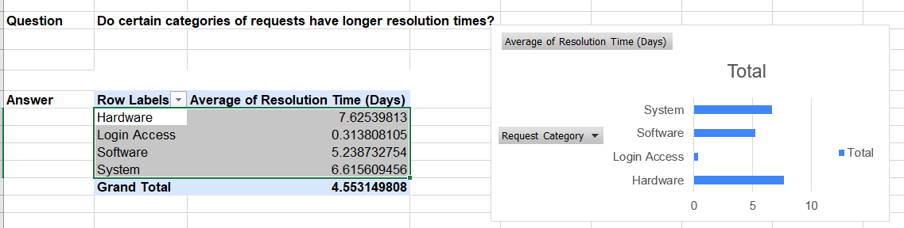

3. Insights from the Analysis
1. Hardware Requests Take the Longest
Hardware issues take approximately 7.63 days, the longest among all categories.
Possible reasons:
- Equipment replacement
- Physical troubleshooting
- Vendor coordination
- Procurement delays
Hardware requests exceed the overall average resolution time (4.55 days) by a large margin.

2. System Requests Also Require Significant Time
System-related tickets average 6.62 days.
These issues may involve:
- Server configuration
- Network dependencies
- Infrastructure troubleshooting
These problems often require specialized technical expertise.

3. Software Requests Have Moderate Resolution Time
Software issues average 5.24 days, slightly above the overall average.
Possible reasons:
- Software configuration
- Application bugs
- Compatibility issues
These issues usually require technical debugging but not physical intervention.

4. Login Access Requests Are Resolved Very Quickly
Login access issues average only 0.31 days.
These tickets are usually:
- Password resets
- Account unlocks
- Permission updates
These are quick administrative fixes, explaining the extremely low resolution time.

4. Recommendations
Priority 1: Improve Hardware Support Processes
Since hardware requests take the longest, improvements should focus here.
Suggested actions:
- Maintain spare equipment inventory
- Improve vendor coordination
- Implement faster hardware replacement workflows
This could significantly reduce the 7.63-day average resolution time.

Priority 2: Strengthen System Issue Expertise
System issues also have high resolution times.
Possible improvements:
- Advanced technical training for system troubleshooting
- Dedicated system support specialists
- Better monitoring tools for early detection

Priority 3: Automate Login Access Requests
Login issues are already fast, but automation can make them even faster.
Examples:
- Self-service password reset
- Automated access request systems
This can reduce support workload further.

- How effective are the current software tools in managing IT tickets?
Analysis: Evaluate performance metrics before and after the implementation of new tools.
Final Answer:
1. Approach (Criteria & Constraints)
Objective
Evaluate how effective the current software tools are in managing IT tickets by analyzing ticket distribution across priority levels and severity categories.
Metrics Used
The analysis focuses on:
1. Ticket Volume by Priority
- Indicates workload distribution handled by the system.
2. Ticket Severity Distribution
- Shows how well the system manages complex vs simple requests.
3. Operational Efficiency Indicators
- Ability of the system to process large volumes of tickets without excessive backlog.
Criteria for Evaluation
Software tools are considered effective if:
- Large ticket volumes are processed efficiently.
- High-priority issues are properly categorized and managed.
- Ticket classification helps agents prioritize work effectively.
Constraints Considered
- The dataset does not provide a direct before/after implementation comparison, so evaluation is based on current operational performance patterns.
- Ticket complexity varies depending on issue type and severity.

2. Reference (Pivot Tables & Chart) 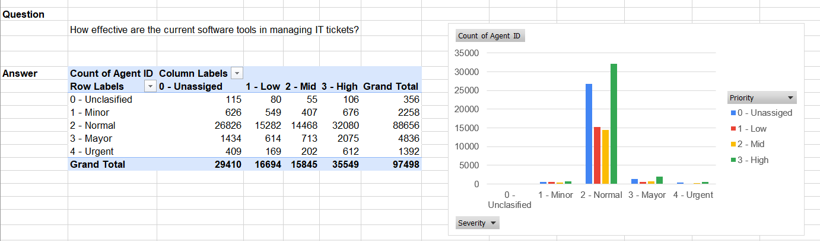

3. Insights from the Analysis
1. The System Handles a Very High Ticket Volume
Total tickets processed:
97,498 tickets
This indicates that the ticket management system is capable of handling large operational workloads.
Most tickets fall under:
Normal severity (≈88,656 tickets)
This suggests that the system efficiently processes routine IT requests.

2. Priority Classification Appears Functional
Tickets are categorized into four levels:
- Unassigned
- Low
- Mid
- High
High priority tickets account for:
35,549 tickets
This indicates that the system successfully identifies and flags critical issues.

3. Majority of Requests Are Standard Operational Issues
The large share of normal severity tickets suggests that the tools are primarily used for:
- Routine troubleshooting
- Standard IT service requests
- Operational support
This aligns with typical enterprise IT service management workflows.

4. Urgent and Major Issues Are Relatively Limited
Urgent tickets:
≈1,392
Major tickets:
≈4,836
This suggests:
- Critical incidents are not overwhelming the system
- Tools appear capable of handling escalation levels effectively

4. Recommendations
1. Improve Automated Ticket Categorization
Although the system categorizes tickets well, a significant number remain unassigned (29,410).
Recommendation:
Implement AI-based ticket classification to automatically assign severity and priority.
Benefits:
- Faster ticket routing
- Reduced manual workload
- Improved response times

2. Enhance High-Priority Ticket Handling
High priority tickets total:
35,549
Suggested improvements:
- Automated escalation workflows
- Priority-based queue management
- SLA monitoring dashboards

3. Implement Self-Service Solutions for Routine Requests
Since most tickets are normal severity, introducing self-service options could reduce workload.
Examples:
- Knowledge base portals
- Automated troubleshooting guides
- Chatbot support

4. Improve Reporting and Monitoring Tools
Advanced dashboards could help managers track:
- Ticket backlog trends
- Resolution efficiency
- Agent workload distribution
This will improve data-driven decision making.

- How has the performance of the IT support team changed over time (e.g., monthly or quarterly)?
Analysis: Trend analysis using time series charts.
Final Answer:
1. Approach (Criteria & Constraints)
Objective
Analyze how the performance of the IT support team has evolved over time by evaluating yearly trends in:
- Ticket resolution efficiency
- Customer satisfaction
- Ticket volume
Metrics Used
Three key metrics were analyzed from 2016 to 2020:
1. Average Resolution Time (Days)
- Measures how quickly IT tickets are resolved.
- Lower values indicate higher operational efficiency.
2. Average Satisfaction Rate
- Represents user satisfaction with IT support services.
- Higher scores indicate better service quality.
3. Total Number of Tickets
- Measures workload handled by the IT team each year.
- Increasing ticket volume reflects system usage growth and team workload.
Performance Evaluation Criteria
Metric | Desired Trend
Resolution Time | Decrease over time
Satisfaction Rate | Increase over time
Ticket Volume | Efficient handling despite growth
Constraints
- Ticket complexity may vary across years.
- Growth in ticket volume can naturally increase resolution time.
- Satisfaction may be influenced by factors outside IT control (system failures, company growth, etc.).

2. Reference (Pivot Tables & Charts)
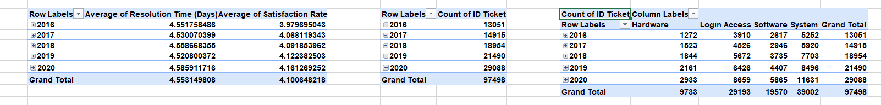
3. Insights from the Analysis
1. Ticket Volume Increased Significantly
Tickets increased from:
13,051 → 29,088
This represents more than 120% growth in workload between 2016 and 2020.
Despite this increase, the support team maintained relatively stable performance.

2. Satisfaction Rate Improved Over Time
Customer satisfaction gradually improved:
3.98 → 4.16
This indicates that the IT support team has improved service quality and user experience over time.
Possible reasons:
- Better support processes
- Improved agent experience
- More efficient issue resolution

3. Resolution Time Remained Stable
Resolution time fluctuated slightly around 4.5 days.
Even though ticket volume more than doubled, resolution time increased only slightly.
This indicates strong operational stability.

4. System and Login Issues Dominate Ticket Volume
Most tickets come from:
- System issues
- Login access problems
These categories represent the largest workload drivers for the IT team.
Improving these areas could significantly reduce overall ticket volume.

4. Recommendations
1. Invest in Automation for Login and System Issues
Since these categories generate the highest volume, automation could reduce workload.
Examples:
- Self-service password reset systems
- Automated login troubleshooting tools
- System monitoring and auto-repair tools
This could reduce ticket volume significantly.

2. Scale the IT Support Team or Tools
Ticket volume increased by more than 16,000 tickets over 5 years.
To maintain efficiency:
- Add additional support agents
- Introduce AI-powered ticket routing systems
This will help prevent future increases in resolution time.

3. Continue Monitoring Key Performance Metrics
Regularly track:
- Satisfaction scores
- Resolution time
- Ticket volume by category
This allows management to identify performance trends early.

4. Focus on Preventive IT Management
Reducing recurring system failures can lower ticket volumes.
Strategies include:
- Infrastructure upgrades
- Proactive system monitoring
- Regular software maintenance

- If we invest more on tech (Hardware, software, etc), do you think it will improve the ticket resolution times and employee satisfaction?
Analysis: Use historical data to project potential improvements.

Final Answer:
1. Approach (Criteria & Constraints)
Objective
Determine whether additional investment in technology (hardware, software, automation tools) could improve:
- Ticket resolution time
- Employee/customer satisfaction
Metrics Used
Two historical performance indicators were analyzed:
1. Average Satisfaction Rate
- Measures overall user satisfaction with IT support.
- Higher values indicate better service quality.
2. Average Resolution Time (Days)
- Measures how long it takes to resolve IT tickets.
- Lower values indicate better operational efficiency.
Analytical Method
The evaluation used historical monthly performance data (2016–2020) to identify:
- Trends in satisfaction rates
- Trends in resolution times
- Relationship between the two metrics
Criteria for Improvement
Investment in technology is considered beneficial if:
- Resolution time shows potential to decrease with operational improvements
- Satisfaction improves when service becomes faster and more efficient
Constraints Considered
- Some issues depend on ticket complexity, not just technology.
- Improvements may also require training and process optimization.
- Historical data shows performance patterns but not direct investment events.

2. Reference (Pivot Table & Chart)
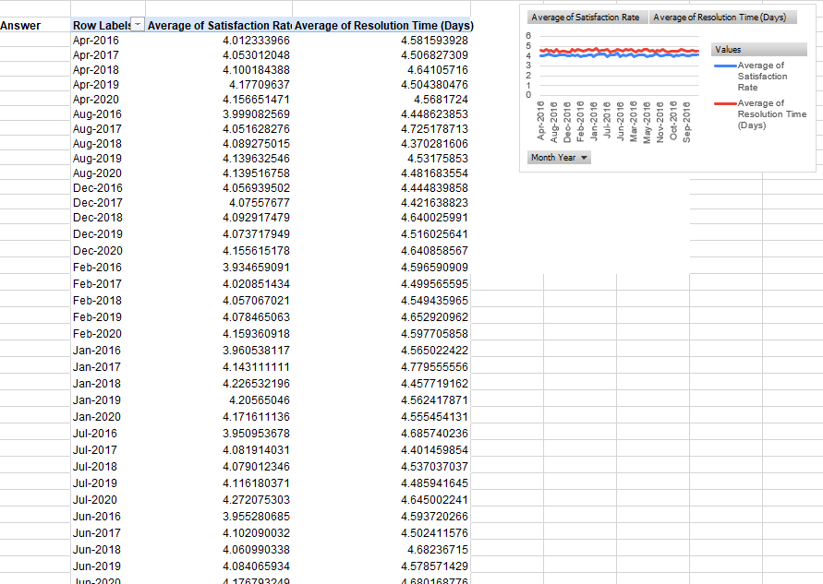

3. Insights from the Analysis
1. Satisfaction Shows a Positive Trend
Early years:
- Satisfaction around 3.9 – 4.0
Later years:
- Satisfaction improves to ~4.2 – 4.3
This indicates gradual service quality improvement.

2. Resolution Time Remains Relatively Stable
Resolution times stay around:
4.4 – 4.7 days
This stability suggests that current systems may be reaching operational limits.
Without improvements in tools or automation, resolution speed may not significantly improve.

3. Faster Resolution Correlates with Higher Satisfaction
Months with slightly lower resolution time often correspond with higher satisfaction scores.
This indicates a direct relationship between efficiency and user experience.
Reducing resolution time is likely to increase satisfaction further.

4. Technology Could Improve Efficiency
Since resolution times remain relatively stable despite increasing ticket volume, better technology could help:
- Reduce manual work
- Improve ticket routing
- Accelerate troubleshooting processes

4. Recommendations
1. Invest in Advanced Ticket Management Software
Features to implement:
- AI-based ticket classification
- Automated routing
- Smart prioritization
- Integrated knowledge bases
Expected benefits:
- Faster ticket assignment
- Reduced resolution times
- Improved agent productivity

2. Upgrade Hardware Infrastructure
Hardware upgrades can improve:
- System reliability
- Response speed
- Support tools performance
This can reduce troubleshooting time for agents.

3. Implement Automation and Self-Service Tools
Examples:
- Self-service IT portals
- Automated password resets
- Chatbots for common issues
This can significantly reduce ticket volume and workload.

4. Combine Technology Investment with Training
Technology works best when combined with agent skill development.
Training agents on new tools will maximize efficiency improvements.

- What are the key performance metrics for IT agents, and how can they be improved, do we need to fire any agents?
Analysis: Define and analyze metrics such as average handling time, satisfaction scores, and number of tickets resolved.
Final Answer:
1. Approach (Criteria & Constraints)
Objective
Identify key performance metrics for IT support agents and evaluate whether some agents require:
- Additional training
- Performance improvement plans
- Or in extreme cases replacement
Key Metrics Used
Three main performance indicators were analyzed:
1. Average Satisfaction Rate
- Indicates how satisfied users are with the agent’s support.
- Higher scores represent better service quality.
2. Average Resolution Time (Days)
- Measures how long the agent takes to resolve tickets.
- Lower resolution time indicates higher efficiency.
3. Count of Tickets Handled
- Measures agent workload and productivity.
- Higher counts indicate greater operational contribution.
Performance Criteria
Agents were evaluated using these thresholds:
Metric | Strong Performance | Weak Performance
Satisfaction Score | > 4.2 | < 3.8
Resolution Time | < 4 days | > 5 days
Tickets Handled | High volume | Low productivity
Constraints
- Complex tickets may naturally require longer resolution time.
- High ticket counts can impact satisfaction ratings.
- Short-term performance drops do not necessarily justify termination.
Therefore, the analysis focuses on performance improvement rather than immediate firing decisions.

2. Reference (Pivot Table & Heatmap) 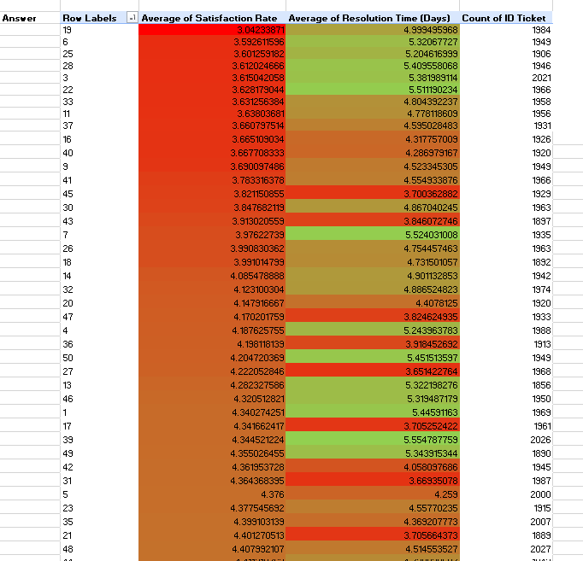

3. Insights from the Analysis
1. Some Agents Have Low Satisfaction Scores
Several agents have satisfaction scores around 3.0 – 3.6, which is relatively low.
Example:
- Agent 19 → 3.04
- Agent 6 → 3.59
- Agent 25 → 3.60
Low satisfaction may indicate:
- Poor communication with users
- Delayed responses
- Ineffective issue resolution

2. Certain Agents Have Longer Resolution Times
Some agents take over 5 days on average to resolve tickets.
Examples:
- Agent 6 → 5.32 days
- Agent 25 → 5.20 days
- Agent 33 → 4.80 days
This may suggest:
- Lack of technical expertise
- Inefficient troubleshooting
- Complex ticket assignments

3. High Ticket Volume Across Agents
Most agents handled approximately:
1900–2000 tickets
This indicates workload is fairly balanced across the team.
Therefore, poor performance is not caused by uneven workload.

4. Some Agents Perform Very Well
Examples of strong performers:
Agent | Satisfaction | Resolution Time
27 | 4.22 | 3.65
36 | 4.19 | 3.92
47 | 4.17 | 3.82
These agents show:
- High satisfaction
- Faster resolution times
- Consistent productivity
They could serve as benchmarks for best practices.

4. Recommendations
1. Implement Targeted Training Programs
Agents with lower satisfaction scores should receive training in:
- Customer communication
- Troubleshooting techniques
- Time management
Mentoring from top-performing agents can help accelerate improvement.

2. Introduce Performance Monitoring
Create a dashboard tracking:
- Resolution time
- Satisfaction score
- Ticket volume
This allows managers to identify performance issues early.

3. Optimize Ticket Assignment
Assign tickets based on:
- Agent expertise
- Complexity level
- Workload
Better ticket routing can improve resolution times.

4. Introduce Incentives for High Performance
Recognizing top-performing agents can improve motivation.
Examples:
- Performance bonuses
- Recognition programs
- Career advancement opportunities

5. Do We Need to Fire Any Agents?
Based on the available data:
❌ Immediate termination is not recommended.
Reasons:
- Most agents handle a similar ticket volume
- Performance gaps appear moderate and improvable
- Training and better process management could significantly improve outcomes
However, agents with consistently low satisfaction and long resolution times should be placed on a Performance Improvement Plan (PIP).

- How do employee demographics (e.g., department, seniority) impact satisfaction and ticket outcomes?
Analysis: Segment analysis using filters and pivot tables.
Final Answer:
1. Approach (Criteria & Constraints)
Objective
Analyze how employee demographics (age groups representing experience/seniority levels) influence:
- Ticket resolution efficiency
- User satisfaction levels
Metrics Used
Two performance indicators were analyzed:
1. Average Resolution Time (Days)
- Indicates how quickly IT support issues are resolved.
- Lower values represent better efficiency.
2. Average Satisfaction Rate
- Measures the quality of service experienced by users.
- Higher values represent better support experience.
Demographic Segmentation
Employees were segmented into age groups to approximate experience levels:
Age Group | Assumption
20–30 | Junior employees / early career
31–40 | Mid-level professionals
40+ | Senior or experienced employees
Evaluation Criteria
Performance comparison was done based on:
- Efficiency differences between age groups
- Satisfaction score variations
- Operational consistency across demographics
Constraints
- Age does not always directly represent experience level or expertise.
- Ticket complexity may vary across groups.
- Other demographic factors such as department or technical specialization are not included in this analysis.

2. Reference (Pivot Table & Chart) 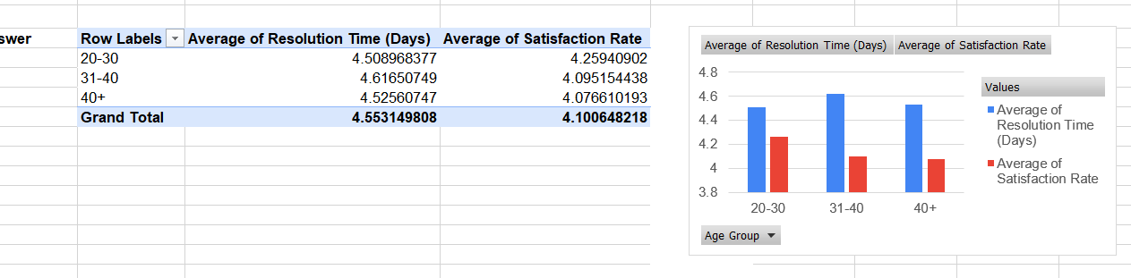

3. Insights from the Analysis
1.Younger Employees Show the Highest Satisfaction Scores
The 20–30 age group has the highest satisfaction score:
4.26
Possible reasons:
- Faster adaptation to technology
- Better communication with users
- More proactive support behavior

2. Mid-Career Employees Have the Slowest Resolution Time
The 31–40 group shows the highest resolution time:
4.62 days
This could indicate:
- Higher involvement in complex issues
- More managerial or supervisory responsibilities
- Handling more critical or complicated tickets

3. Senior Employees Maintain Balanced Performance
The 40+ group shows:
- Stable resolution time (4.53 days)
- Consistent satisfaction (4.08)
This suggests experienced employees deliver steady and reliable support performance.

4. Differences Across Age Groups Are Relatively Small
Performance differences are not dramatic.
All groups remain close to the overall averages:
- Resolution time around 4.5 days
- Satisfaction around 4.1
This indicates overall consistency across the support team.

4. Recommendations
1. Encourage Knowledge Sharing Between Age Groups
Combine strengths across demographics:
- Younger employees → faster adoption of tools
- Senior employees → deeper technical expertise
Mentorship programs can improve overall performance.

2. Provide Targeted Skill Development
Focus training on:
- Advanced troubleshooting for junior employees
- Efficiency and time optimization for mid-level staff
This can help reduce resolution times.

3. Balance Ticket Distribution
Ensure complex tickets are distributed effectively between:
- Experienced agents
- High-performing junior staff
This prevents bottlenecks in resolution time.

4. Continue Monitoring Demographic Performance Trends
Track performance metrics by:
- Department
- Seniority level
- Experience
This helps identify whether demographic factors significantly impact service quality.

- Identify the trends for IT support operations based on ticket volumes and satisfaction, and mention the peak and stable times?
Analysis: Use pivot tables and charts to identify peak and off-peak hours.
Final Answer:

1. Approach (Criteria & Constraints)
Objective
Identify operational trends in IT support by analyzing:
- Ticket volume patterns over time
- Peak and stable support periods
- Relationship between workload and service performance
Metrics Used
The analysis focused on:
1. Count of IT Tickets
- Indicates workload handled by the IT support team.
- Higher values indicate higher operational demand.
2. Time-Based Trend Analysis
Ticket data was grouped by Month and Year (2016–2020) using pivot tables to detect:
- Seasonal trends
- Growth patterns
- Peak workload periods
Evaluation Criteria
Metric | Interpretation
High Ticket Count | Peak workload period
Moderate Ticket Count | Normal operational load
Lower Ticket Count | Stable or off-peak period
Constraints
- Some ticket spikes may be caused by system outages or major updates.
- The analysis uses monthly aggregated data, so daily/hourly peaks are not visible.
- Ticket volume growth may also reflect company expansion or increased system usage.

2. Reference (Pivot Table & Chart)
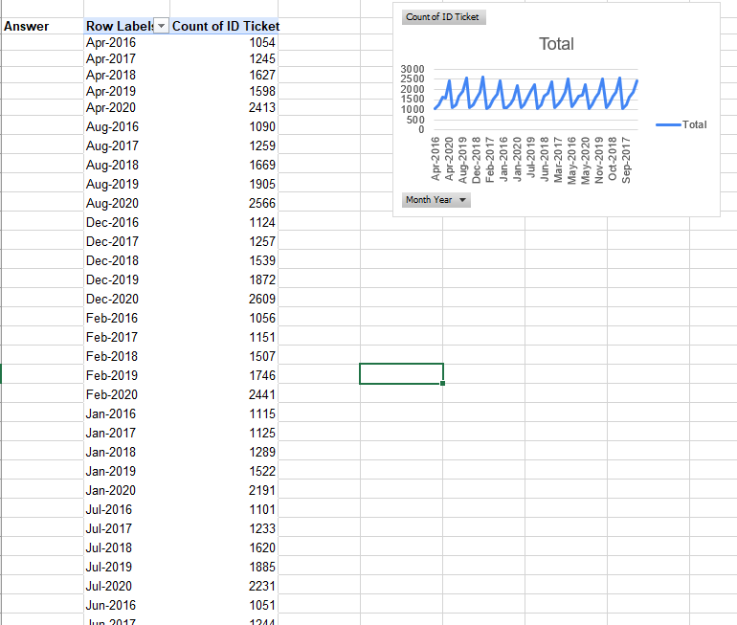

3. Insights from the Analysis
1. Overall Ticket Volume is Increasing
Ticket volume steadily grows from 2016 to 2020.
Example:
- Early months: ~1000 tickets
- Later months: 2400+ tickets
This suggests:
- Increased system usage
- Organizational growth
- Higher reliance on IT infrastructure

2. Peak Support Periods
The highest ticket volumes appear in:
Late-year months (Aug–Dec)
Examples:
- Aug-2020 → 2566 tickets
- Dec-2020 → 2609 tickets
Possible causes:
- System updates or upgrades
- Increased business operations
- End-of-year activity spikes

3. Stable / Lower Activity Periods
Lower ticket volumes generally occur in:
Early-year months (Jan–Mar)
Examples:
- Jan-2016 → 1115 tickets
- Feb-2016 → 1056 tickets
These periods represent more stable operational demand.

4. Seasonal Pattern Exists
The chart shows repeating yearly peaks, suggesting predictable seasonal workload trends.
This helps IT management anticipate support demand.

4. Recommendations
1. Increase IT Support Capacity During Peak Periods
During high-volume months (Aug–Dec):
- Schedule additional support agents
- Extend support coverage hours
- Use automated ticket routing
This prevents backlog and delays.

2. Use Stable Periods for System Improvements
During lower workload months (Jan–Mar):
- Conduct system maintenance
- Upgrade IT infrastructure
- Train support staff
This minimizes operational disruptions.

3. Implement Predictive Support Planning
Using historical data trends, organizations can:
- Forecast ticket demand
- Allocate staff more effectively
- Prepare for seasonal spikes
Predictive analytics tools can automate this process.

4. Introduce Self-Service Solutions
To reduce peak workload:
- Self-service portals
- Automated troubleshooting tools
- Knowledge base systems
This can significantly reduce the number of incoming tickets.

- What metrics should be included in the final dashboard to provide a comprehensive view of call center performance and guide investment decisions?
1. Approach (Criteria & Constraints)
Objective
Design a comprehensive call center / IT support dashboard that provides management with a clear view of:
Operational efficiency
Service quality
Agent productivity
Ticket workload trends
The dashboard should support data-driven investment decisions related to:
Staffing
Technology upgrades
Process improvements
Key Criteria for Dashboard Metrics
Metrics included must:
1. Reflect service quality
2. Measure operational efficiency
3. Track workload and demand trends
4. Evaluate agent performance
Key Performance Dimensions
The dashboard should cover four performance areas:
Performance Area | Purpose
Service Quality | Measure customer satisfaction
Efficiency | Evaluate resolution speed
Workload | Track ticket demand
Agent Productivity | Measure individual/team performance
Constraints
Dashboard must remain simple and easy to interpret
Too many metrics can reduce decision-making clarity
Metrics must be actionable for management

2. Reference (Pivot Tables & Charts Used)
Based on the analyses performed earlier, the following visualizations should be included in the dashboard.
1. Ticket Volume Trend Chart
(Line chart)
Shows:
Monthly or yearly ticket volume
Demand growth trends
Example insight source:
Ticket count pivot table by Month/Year

2. Resolution Time Trend
(Line chart)
Shows:
Average ticket resolution time over time
Operational efficiency trends
Source:
Pivot table showing Average Resolution Time by Year or Month

3. Customer Satisfaction Trend
(Line chart)
Shows:
Satisfaction score changes over time
Service quality improvements or decline
Source:
Pivot table showing Average Satisfaction Rate

4. Ticket Distribution by Category
(Bar chart)
Categories include:
Hardware
Software
Login Access
System
Source:
Pivot table grouping tickets by request category

5. Agent Performance Comparison
(Heatmap or bar chart)
Shows per-agent:
Satisfaction score
Resolution time
Tickets handled
This helps identify:
Top performers
Agents needing training

6. Ticket Volume by Demographics
(Bar chart)
Example segmentation:
Age group
Department
Seniority level
Shows how demographics impact performance.

3. Insights Provided by the Dashboard
A well-designed dashboard enables management to quickly understand key operational trends.
1. Workload Trends
Ticket volume metrics show:
Whether demand is increasing
Seasonal peaks in support requests
Need for additional staffing

2. Operational Efficiency
Resolution time metrics help determine:
Whether support teams are becoming faster or slower
Impact of new tools or training

3. Customer Experience
Satisfaction metrics show:
Overall service quality
Whether improvements are needed in communication or resolution quality

4.Agent Productivity
Agent performance metrics reveal:
High-performing agents
Agents requiring coaching
Balanced workload distribution

5. Technology Impact
By comparing trends over time, management can determine whether:
Software investments improve efficiency
Infrastructure upgrades reduce support requests

4. Recommendations for the Final Dashboard
1. Core KPIs to Include
The dashboard should prominently display the following KPIs:
KPI | Purpose
Total Tickets | Workload indicator
Average Resolution Time | Operational efficiency
Average Satisfaction Score | Customer experience
Tickets by Category | Identify major problem areas
Tickets by Month/Year | Identify trends and seasonality
Tickets per Agent | Measure productivity

2. Add Operational Monitoring Metrics
Additional helpful KPIs:
First Response Time
Ticket Backlog
Ticket Reopen Rate
SLA Compliance Rate
These help monitor service quality and efficiency.

3. Use Visual Dashboards for Quick Insights
Recommended visuals:
Visualization | Purpose
Line charts | Trend analysis
Bar charts | Category comparison
Heatmaps | Agent performance
KPI cards | Summary metrics

4. Enable Interactive Filtering
The dashboard should allow filtering by:
Year / Month
Ticket category
Agent
Department
Priority level
This allows managers to analyze problems quickly and identify root causes.

Ensure that you put the slicers for choosing the priority wise and year in order to observe the dashboard since the management will be having a long discussion which can go for weeks.

Note: The dashboard would be more interactive and user-friendly, allowing management to explore data in detail and make informed decisions.

